lab 1

Part 1 :

Voltage divider

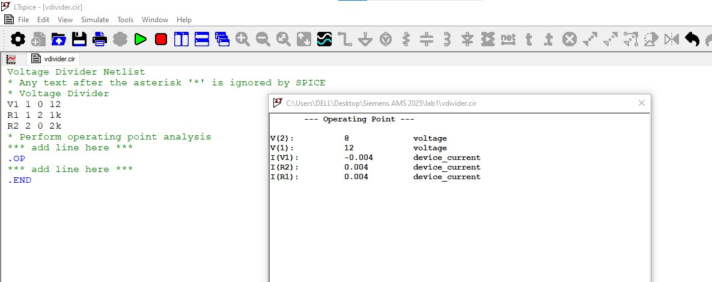

AC

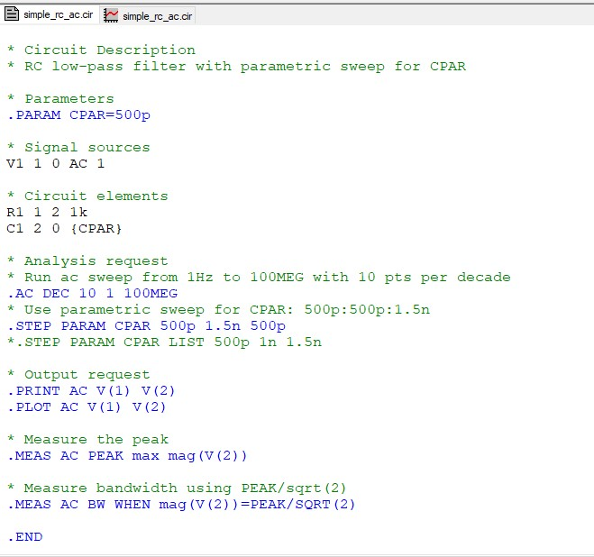

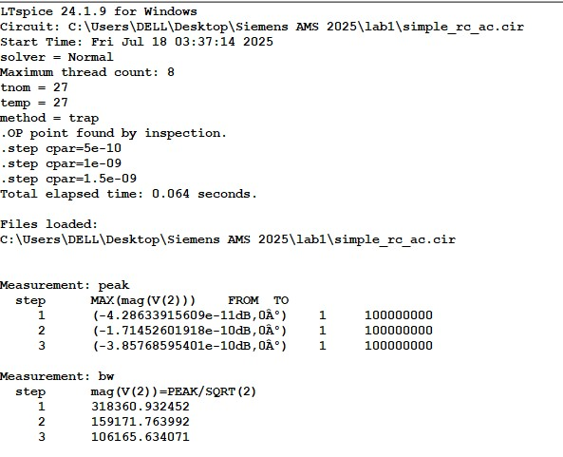

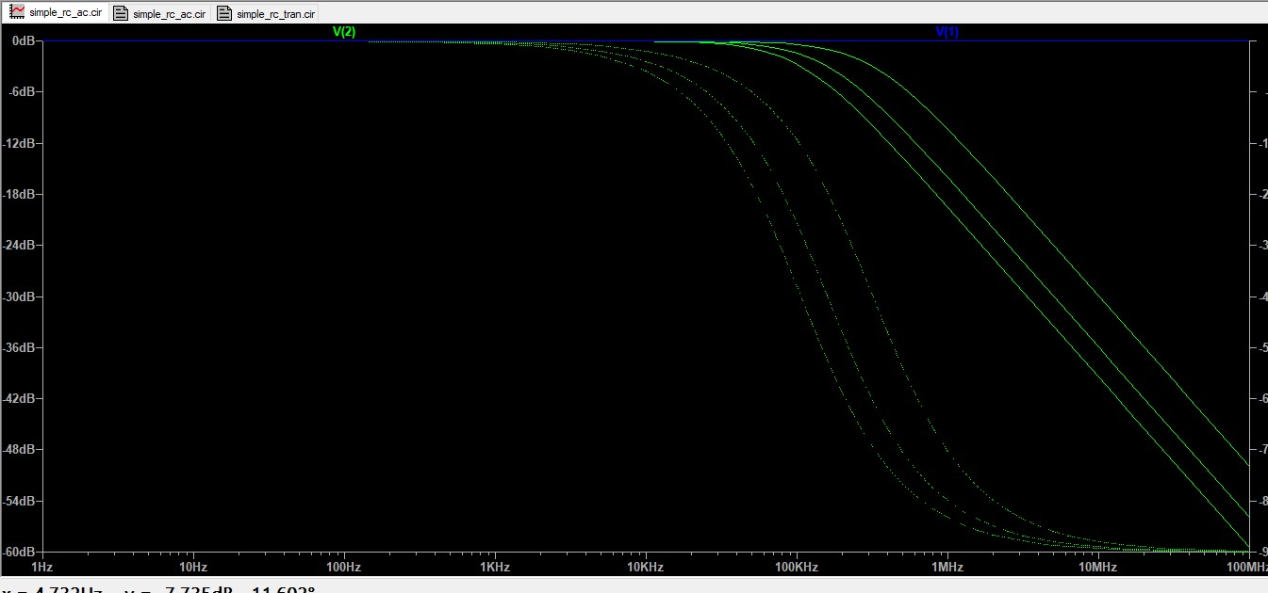

Transient

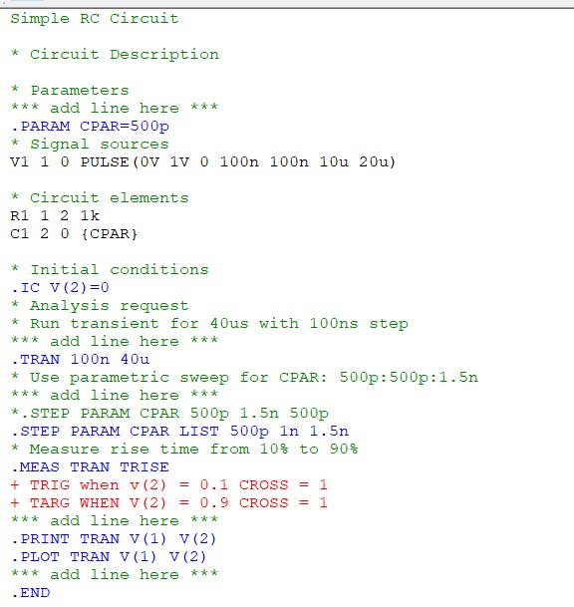

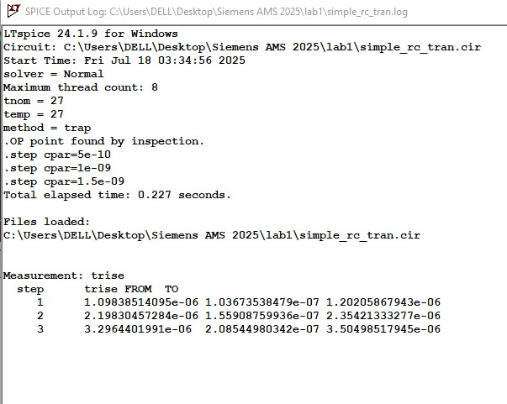

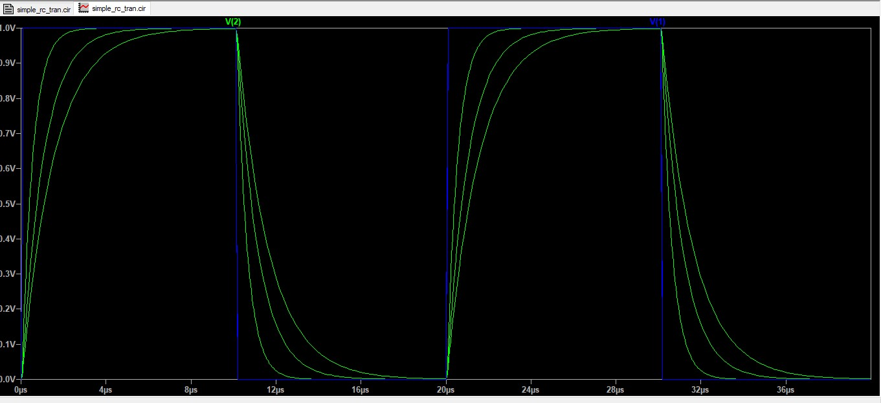

Part 2:

1. 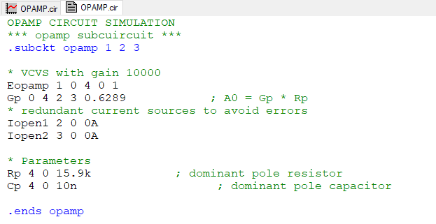

Given : A0 = 10000 and UGF= 10MHz. fp=1KHz

RpCp = = =159.23 u

Assumed Rp =15.9 Kohm , Cp = 10nF

GP = A0/Rp = 0.6289

1. 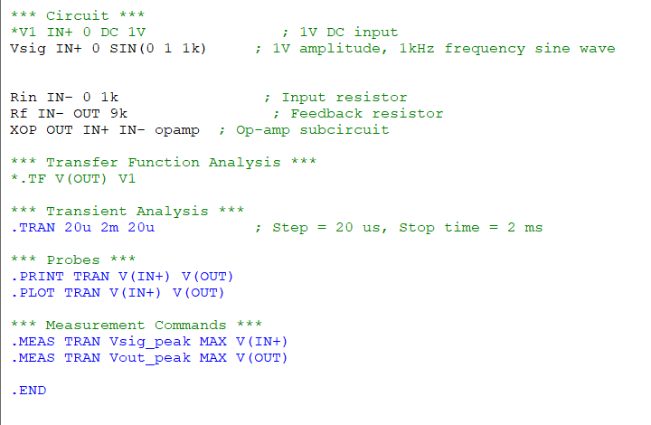

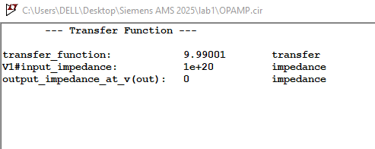

We can see that transfer function = = 9.99 and the TF analatically =10

Very large input impedance(ideally infinity) and small output impedance(ideally 0) and that matches the predicted from the opamp analysis

1. 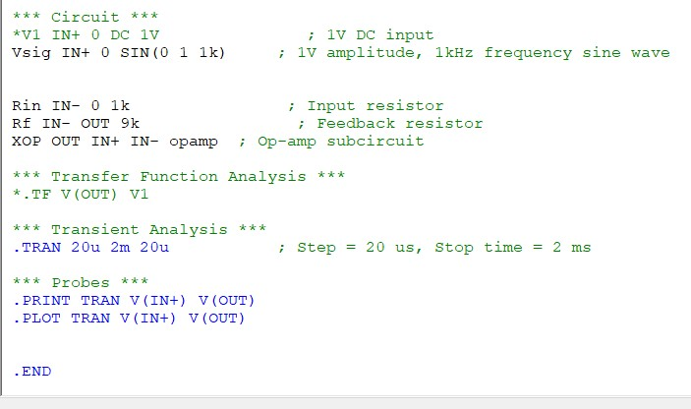

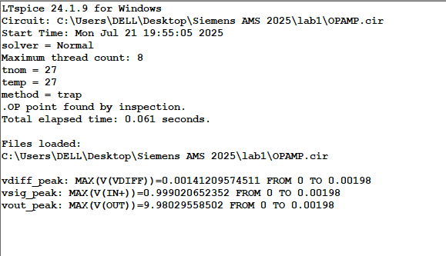

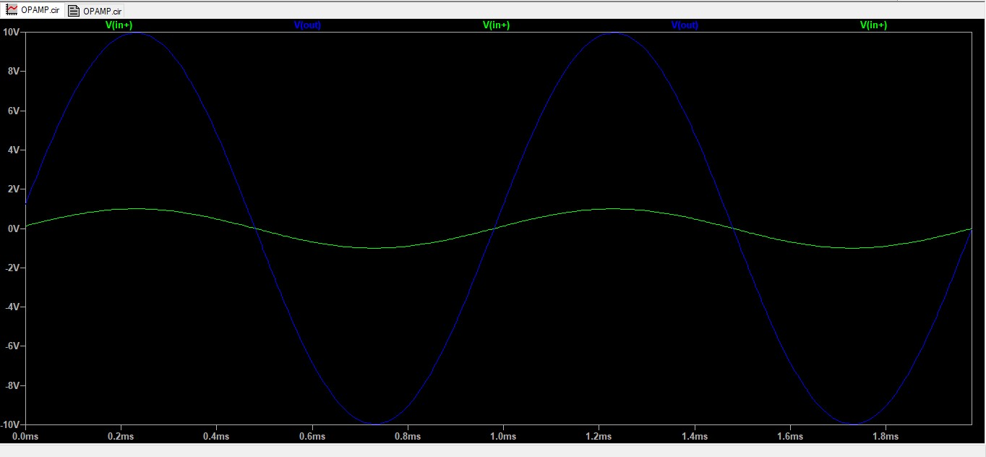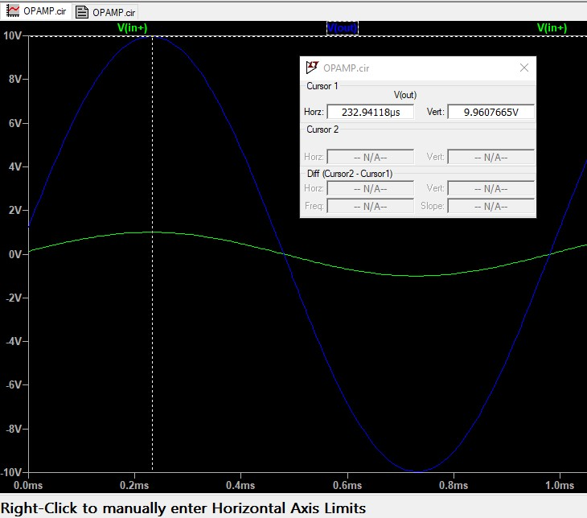

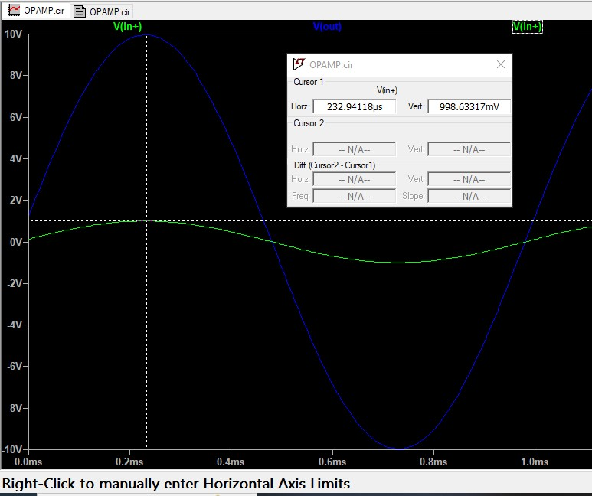

1. from the measured peaks of Vsig and Vout

Av= Vout / Vsig = = 9.99

|  |  |  |
| --- | --- | --- |
| Hand analysis | TF analysis | Transient analysis |
| Av = 1+ = 10 | From TF log Av=9.9901 | Av=9.99 |

We can see that the analytical way gives the most accurate results although LTspice gives good results also for both TF analysis and Transient analysis

1. • At **1 kHz**, the op-amp has high gain → feedback works → differential input is **very small**.

• At **10 MHz**, the op-amp can no longer amplify → feedback fails → differential input is **larger**

Differential voltage for frequency 1KHz



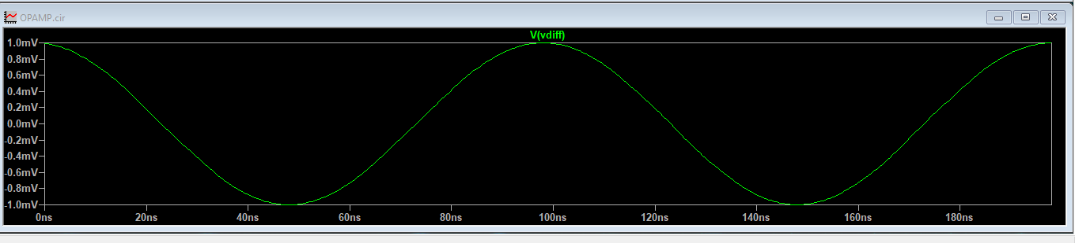

The amplitude of Vdiff = 1mV nearly .

**Hand analysis:**

At low frequency, the output is:

Vout = Av * Vsig = 10 *1 = 10 V

So The differential input voltage is approximately:

Vdiff = Vout / A0 = 10 / 10000 = 1mV

Differential voltage for frequency 10MHz

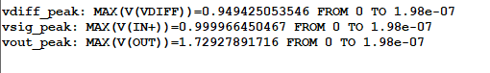

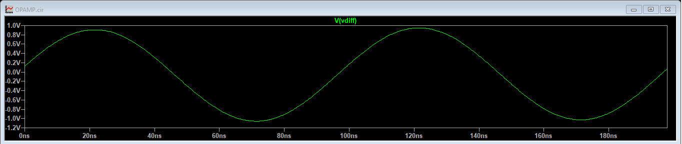

The amplitude of Vdiff = 1V nearly .

**Hand analysis:**

At UGF, the op-amp's open-loop gain drops to 1 : A0(f=UGF) = 1

The feedback will not work properly and the differential voltage will be close in value to output voltage with very small gain ( nearly no gain ).

1. Netlist :

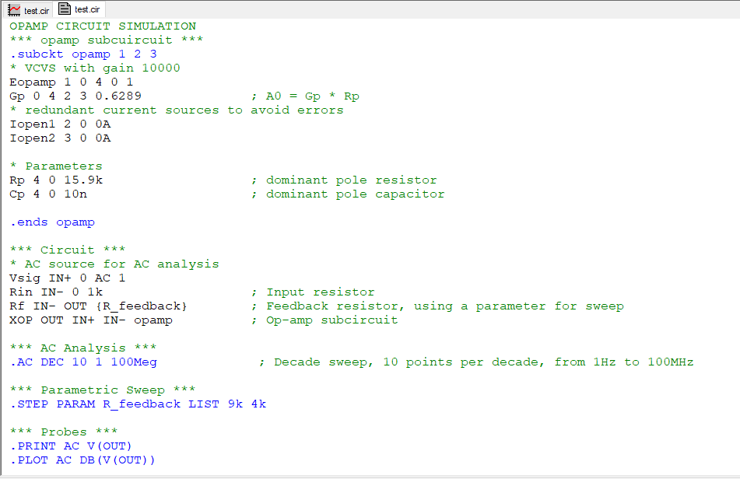

Waveform :

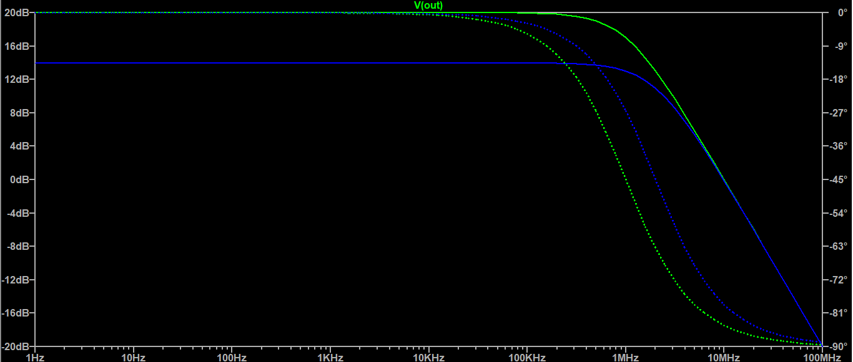

GAIN

For the case RF = 4k : GAIN= 14dB

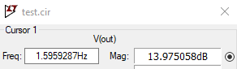

For the case RF = 9K : GAIN = 20dB

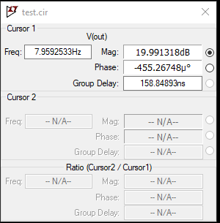

3dB Bandwidth

For the case RF = 4k : BW= 2MHz

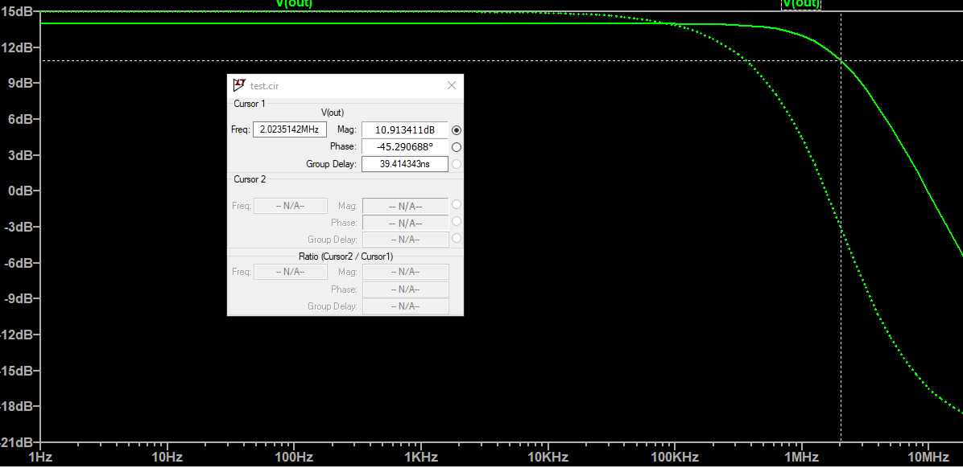

For the case RF = 9k : BW= 1MHz

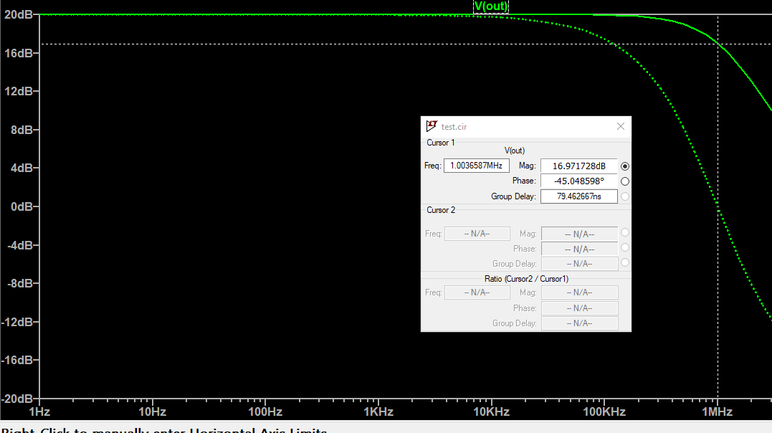

Unity Gain Frequency :

For the case RF = 4k : UGF= 9.85MHz (nearly) 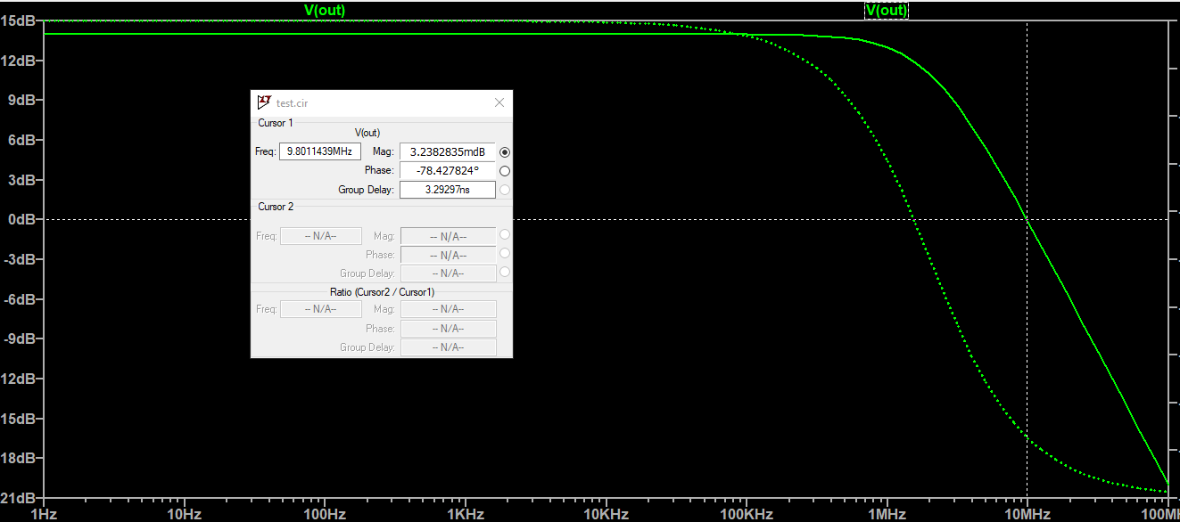

For the case RF = 9k : UGF= 9.95MHz (nearly)

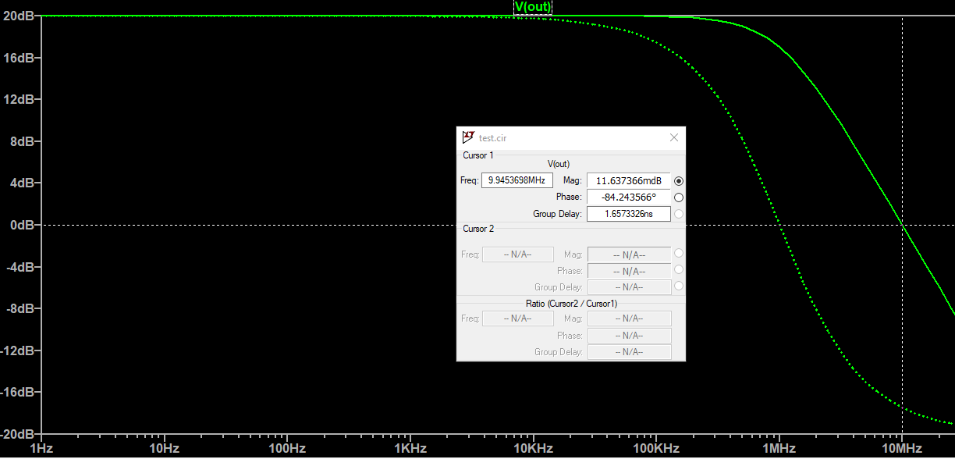

1. **AC Analysis**

There will be no clipping in the output because this is linear small-signal analysis that analyses the response with frequency , The simulator scales everything linearly and does not consider nonlinearities but we can achieve higher gain if the input amplitude increases .

**Transient Analysis**

you can see clipping in transient analysis if the output tries to go beyond the op-amp's output voltage limits (supply rails) because this is a time-domain simulation and applies real large voltages on the circuit

1. **DC Gain :**

Av =1+

For RF = 9K : Av =20log( 1+ (9K/1K) ) = 20dB

For RF = 4K : Av =20log( 1+ (4K/1K) ) = 14dB

**Bandwidth:**

Bw=

For RF = 9K , UGF = 10MHz : BW= 10M / 10 = 1MHz

For RF = 4K , UGF = 10MHz : BW= 10M / 5 = 2MHz

**Unity Gain Frequency**:

Circuirt was designed for UGF = 10MHz so it is for the two cases

|  |  |  |
| --- | --- | --- |
| Parameter | Hand Analysis | AC analysis |
| DC Gain | RF=4K ==> 14dB  RF=9K ==> 20dB | RF=4K ==> 13.975dB  RF=9K ==> 19.99dB |
| 3dB Bandwidth | RF=4K ==> 2MHz  RF=9K ==> 1MHz | RF=4K ==> 2MHz  RF=9K ==> 1MHz |
| UGF | RF=4K ==> 10MHz  RF=9K ==> 10MHz | RF=4K ==> 9.8MHz  RF=9K ==> 9.945MHz |

BONUS ( Non Inverting Summing Amplifier ) :

Netlist :

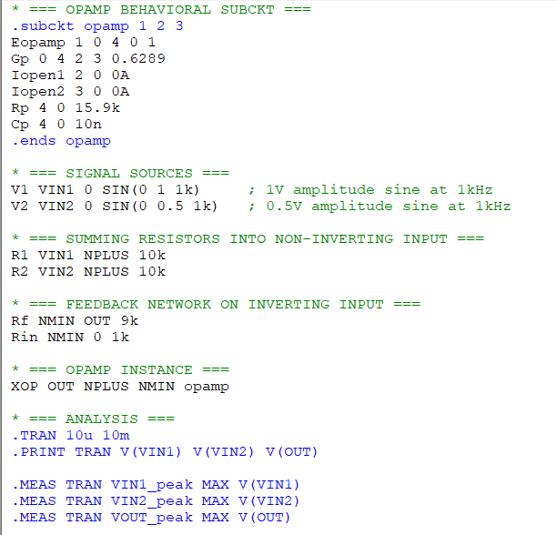

Measurement :

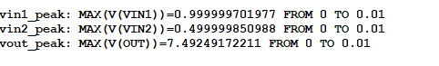

Wave form :

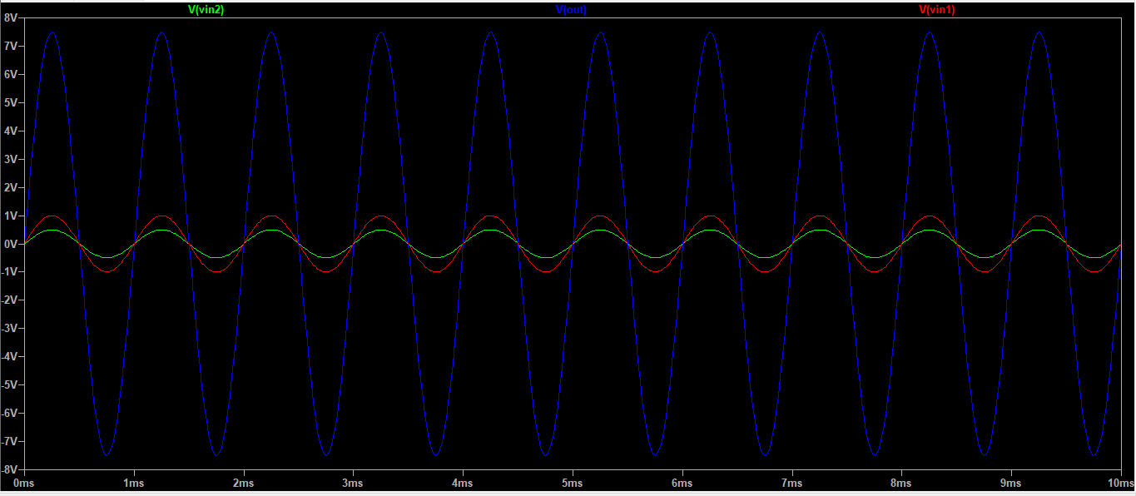

Components :

1. Two AC sources at frequency 1KHz with amplitudes 1 , 0.5 Volts
2. Two summing resistors equal 10Kohm
3. Feedback resistor equals 9Kohm
4. Input resistor equals 1Kohm

**Analysis :**

Av = 1+ = 10

V+​=​​ (equal resistor weights)

Vout = Av * V+ = 10 * 0.75 = 7.5 V

Voltage gain = Vout / Vsig = = 5

TF Analysis :

We perform TF analysis on each source with the output and we find the results are identical and the voltage gain is near to the gain we obtained from Transient analysis

